

nEWS rELEASE – fOR immediate release

CONTACTS:
Robin Rose – Frederick Health / rrose@frederick.health
Kristen Fraser - Truist / kristen.fraser@truist.com
FREDERICK HEALTH RECEIVES $250,000 GRANT FROM TRUIST
FOR REENVISIONING CRITICAL CARE CAMPAIGN
FREDERICK, MD, January 16, 2023 – Frederick Health today announced it received a $250,000 grant from Truist, via its Charitable Fund and Foundation, for the ReEnvisioning Critical Care Campaign to help fund the renovation and expansion of the hospital’s critical care service areas.
"We are incredibly grateful to Truist for its generosity and continued commitment to the health of the Frederick community. Philanthropy is vital to Frederick Health’s ability to grow and change to meet the needs of our community. We are fortunate to have a great corporate citizen in Truist,” said Frederick Health President & CEO Tom Kleinhanzl.
The ReEnvisioning Critical Care project is a $46 million capital construction project on the hospital’s 7th Street campus to redesign the emergency department to accommodate adult and pediatric patients, modernize the intensive care unit and expand diagnostic and therapeutic cardiac services to meet current and future demand. The project is expected to be completed in early 2024.
“Access to high-quality care is an essential pillar for thriving communities,” said Greg Farno, regional president for Truist’s Maryland region. “Through this significant grant, Truist is recognizing the important role Frederick Health plays in the lives of individuals and families in our region and it’s a tangible way we can bring to life our purpose to inspire and build better lives and communities.”
Check Presentation Photo
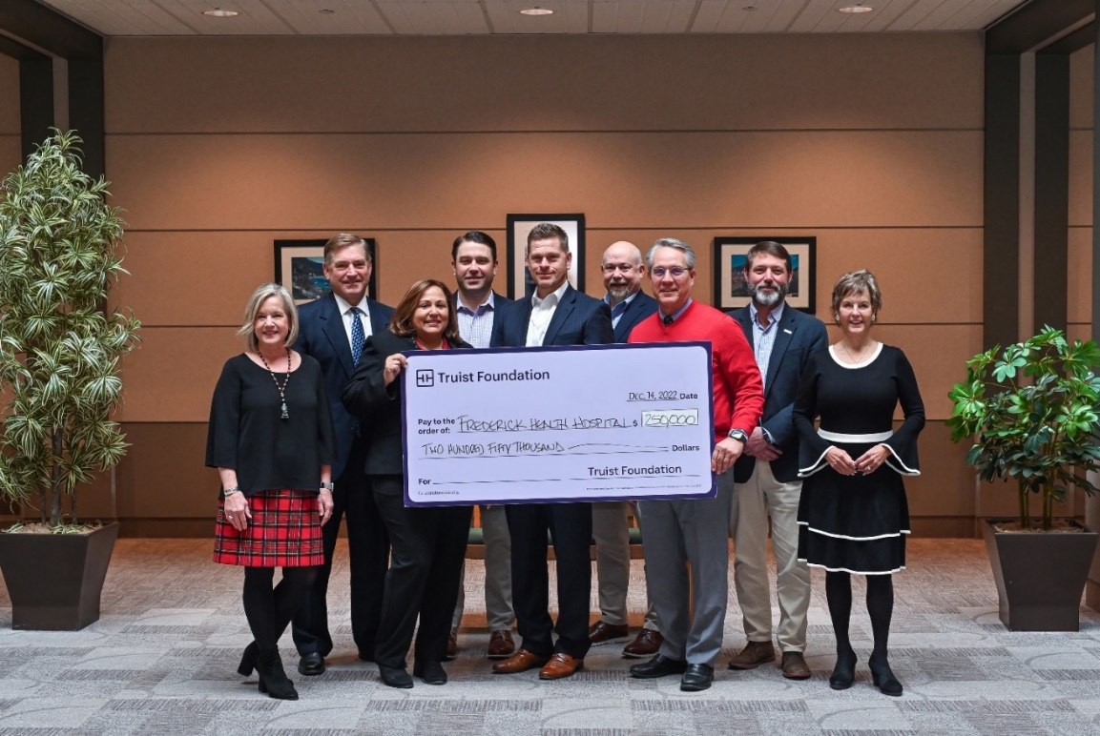

About Frederick Health
Frederick Health provides comprehensive healthcare services to the residents of Frederick County and beyond. The system includes Frederick Health Hospital, Frederick Health Medical Group, Frederick Health Employer Solutions, Frederick Health Home Care, and Frederick Health Hospice. Frederick Health Medical Group is a multi-specialty practice with more than 100 providers, 18 specialties, and 24 locations across the County. The system has several ambulatory care locations, the freestanding James M Stockman Cancer Institute, three urgent care locations, and the Frederick Health Village. With over 4,500 team members, Frederick Health provides a full spectrum of healthcare and wellness services to support its mission to positively impact the well-being of every individual in our community. For more information, visit frederickhealth.org.
About Truist Foundation
Truist Foundation is committed to Truist Financial Corporation’s (NYSE: TFC) purpose to inspire and build better lives and communities. Established in 2020, the foundation makes strategic investments in nonprofit organizations to help ensure the communities it serves have more opportunities for a better quality of life. Truist Foundation’s grants and activities focus on building career pathways to economic mobility and strengthening small businesses. Learn more at Truist.com/Foundation.
# # # #

